Movie Database Software Requirements

# Goals

# User Stories

As a <User>, I want <Goal> so that <some reason>

TASK: Complete User story for trending hashtags and next page functionality

* As a user, I want to see a list of movies so that I can be able to sort them later.
* As a user, I want to be able to sort the list of movies by rank, id, and title so that I can see the rankings better.

# Flow Diagram(Swimlane)

Shows who does what in the process (Example)

TASK: Complete Swimlane for next page click

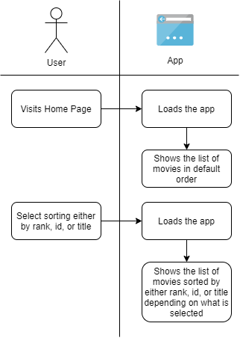

# Business Requirements

TASK: Complete Business Requirements for Home Page

* Allow a user to view the list of movies
* Allow a user to sort movies by rank, id, or title

# Technical Requirements

* None

### Swim Lane Diagram Example

Credit: lucidchart.com

